The researchers were interested in examining the differences in quality of manufacturing medical wires using different machine types and reduction angles. The study also examines these differences while accounting for the bearing separation lengths of the wires. Since this is a 2X2 experiment to find differences in means for a single dependent variable and accounts for another variable, I would recommend using ANCOVA. This method is used for experiments that focus on differences in means and accounts for the strong correlation between the dependent variable and the covariate.

The assumptions for ANCOVA are as follows: There should be random sampling, i.e. a wire should have equal chances to be in any of the four groups. This assumption can be easily achieved through the design of the experiment. The other assumption is to have univariate normality for the dependent variable for each of the four treatment groups. The plots for the univariate normality did not follow a perfect normal distribution, but the results of ANCOVA can be used due to the robustness from having a balanced design experiment. Finally, the last assumption is to have a strong correlation between the dependent variable and the covariate. The following scatter plot and table indicate that there is a strong correlation between the dependent variable RATIO and the covariate LENGTH.

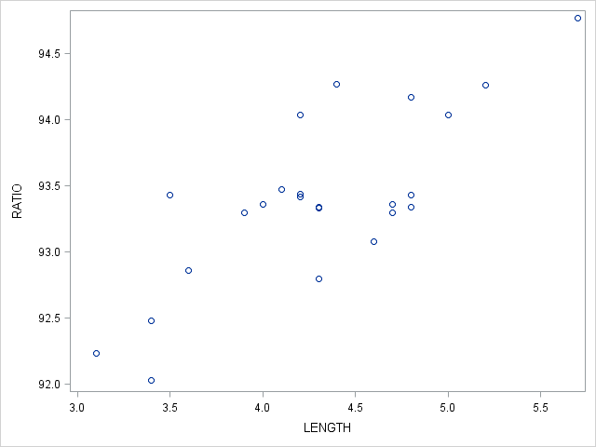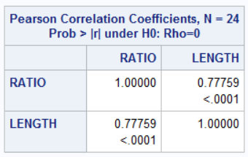

After running the ANCOVA and testing for the interaction between the type of machine and the reduction angle, we were able to find significant differences in the means only for the groups when the angles have changed. The interaction term and the main effects for the type of machine did not report a significant difference in means.

Using Bonferroni’s test, we were able to identify that using an angle with wide reduction angle has a significantly higher mean for RATIO at 93.71 than the narrow reduction angle which was 93.08.

**Appendix**

Below is the output from the ANCOVA procedure using SAS code

